The Satires Of Juvenal

By Peter Coglan May 2026

From The Medium Website:

https://medium.com/@p.coglan/the-satires-of-juvenal-1-10974555d59d?postPublishedType=repub

Chapter 1 — Rome’s Infamous Lifestyle Critic
I first gave this talk on Juvenal at Warrington U3A Classical History Group in 2018. I published the updated talk notes as an article on Medium in July 2025, but 10 months later it warrants an update on Medium and here. Satire has had a renaissance in recent months in Britain, and I wanted to reflect that.

An Artist Impression of Juvenal (Image. Britannica)
First Encounter
When I studied Juvenal at University 50 years ago, the authority on the Roman satirist was Gilbert Highet, who devotes 35 pages to the satirist’s life in his book of 1954. But the more recent the book on Juvenal the more the view is that we know very little indeed about him. I managed to summarise Juvenal in 35 words: “Juvenal was born in Aquinum around 55AD. He was probably a rhetor in his early life. He wrote 16 Satires in 5 books. He was probably exiled for a short while. He died around 138AD.”
So, that’s it, all done.
Or perhaps not. A couple of lines half way through Juvenal’s first satire do seem rather appropriate to this article: ‘quidqud agunt homines…nostri farrago libelli est’, translated as “whatever people do, that’s the hotchpotch of my little book”. My article is a farrago (or hotch-potch) too. As we do not know much about Juvenal, I can only tell you about his satires, and how I see them. The meaning of poetry of any type, particularly poetry written so long ago, is always a matter of opinion and the interpretation of the person doing the review.
I will try to cover what satire is, or at least what it was at the time Juvenal was writing, what little we know about Juvenal, what his satires covered, and what has happened to satire as a genre in my lifetime. I will also try to relate the satires to the 21st C. Some things do keep recurring down the ages, and we have a new group of people in public life who are being deservedly lambasted on social media with the aid of AI software tools only recently widely available.
Even though many people have never heard of Juvenal — try asking someone if they have — there are some sayings used to this day that come from his satires — “bread and circuses”, “a sound mind in a healthy body”. Those sayings are both lifted from Juvenal, and there are one or two others as well.
What Is Satire?
So what is satire? Well according various dictionaries, satire is a genre of literature, and sometimes graphic and performing arts, in which vices, follies, abuses, and shortcomings are held up to ridicule. The intent, ideally, is to shame individuals, corporations, government, or society itself into improvement. Although satire is usually meant to be humorous, its greater purpose is often constructive social criticism, using wit to draw attention to both particular and wider issues in society.
Satire can contain strong irony or sarcasm, also parody, double entendre, and exaggeration. At its most extreme I think it ends up as lampoon. In recent times a lot of satire has been written for visual or performance rather than reading, and so that is where much satire has ended up. But you can see that satire can be formed from, or can contain multiple genres and forms of literature, rather than be a single form.
Satire does not have to be humorous even if it often is. The intention is to make the reader/watcher smile or laugh, and then think about they have read, heard or seen.
The word satire originally derives from the word satur meaning full — think “satiated” or “satisfied”. More specifically there was a phrase ianx satura, literally meaning a dish full of fruit and nuts. The extended meaning therefore becomes a miscellany or medley. So Juvenal’s use of the word farrago, also meaning hotch-potch or miscellany, to describe his satires is quite appropriate.
Early Satire
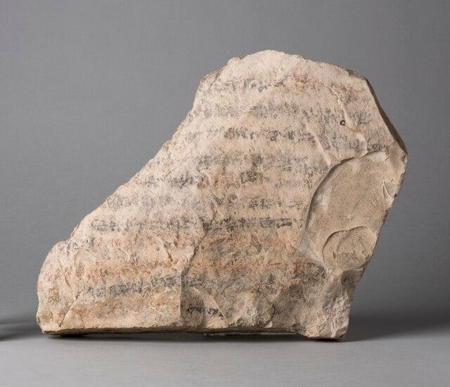
The Satire of the Trades (Photo: Wikipedia)
Two of the earliest examples of written satire are considered to be Egyptian. One called “The Satire of the Trades” is in Egyptian writing from the beginning of the 2nd millennium BC. The text’s readers are probably students, tired of studying. The work argues that their role as scribes is useful, and their lot far superior to that of the ordinary man. Some scholars think that the context was meant to be serious.
The “Papyrus Anastasi” (late 2nd millennium BC) contains a satirical letter which first praises the virtues of its recipient, but then mocks the reader’s meagre knowledge and achievements as well as mocking the incompetence of specific individuals.
The Greek comic playwright Aristophanes is regarded as an early satirist. His plays often mocked the behaviour of leading political figures of his day, particularly Cleon, but also other well-known people such as the philosopher Socrates. The playwright Menander also attacked politicians in his comedies.
There is a third Greek writer, Menippus of the 3rd C BC, though none of his work survives, but his type of work is now referred to as Menippean. This form of satire is usually in prose, with a length and structure similar to a novel. It is characterized by attacking mental attitudes rather than specific individuals or entities. The term is used by classical grammarians and by philologists, mainly to refer to satires in prose.
Roman Satire
The first Roman reference to satire is the author Quintilian, who invented the term I mentioned earlier, ianx satura, to describe the writings of Gaius Lucilius, 2nd C BC. Only fragments remain of Lucilius’s work but he is regarded as the first satirist. From the fragments that remain, largely quoted by later writers, he wrote about matters of daily life, the politics, the wars, the administration of justice, the eating and drinking, the money-making and money-spending, the scandals and vices, which were part of the public and private life of Rome in the last quarter of the 2nd C BC.
The first well known and influential Roman poet to use satire was Horace. He wrote 2 books of Satires between 35BC and 30BC. It seems Lucilius was a great influence on his work. Horace wrote satires on daily life and the search for human happiness. In his second book the satires take the form of dialogues with both people from his daily life, and mythical characters, as though they were philosophers. Horace also published a great deal of non-satirical work, particularly his Odes and Epistles, and he is better known for these.
I have a Loeb edition of Juvenal’s work. It includes the satires of both Juvenal and another satirist Persius. The latter lived a short life between 34AD and 62AD. He was a Stoic pupil and was trained to work in the law courts. His work was published and possibly edited by his friend Cornutus after his death. The six satires of Persius cover a number of subjects including what he sees as a lower standard of literary writing because of a lowering of public morals. So the works of Persius would probably have been available to Juvenal when he began to write satire. What had evolved by then was a style of poetry offering a critical commentary on daily life or current affairs, using a tried and tested meter known as the dactylic hexameter.
A large portion of ancient writing was initially produced to be read aloud in public as opposed to be read from a scroll. Most of the population had little or no reading ability. There was no printing press, typewriter, or word processor in Ancient Rome, few bookshops (and those were not like a branch of Waterstones), and few public libraries. So even prose was written in a way that made reading aloud more attractive to the listener, hence the use of meter.
The various meters go back to Greek writing or earlier and involved a specific rhythm being used that the words had to fit, perhaps a forerunner of what we call songs today. In fact some people have recently commented on similarities between classical meters and the rhythms used in modern hip hop and rap. The performance could well have had similarities as hip hop and rap are spoken to a rhythm or beat as opposed to sung. For anyone who has studied Latin, this is why works by Latin authors do not follow the supposedly strict word order that courses start off teaching you, as the words were moved around to fit the meter.
The dactylic hexameter used by Juvenal and others consists of six “feet”.
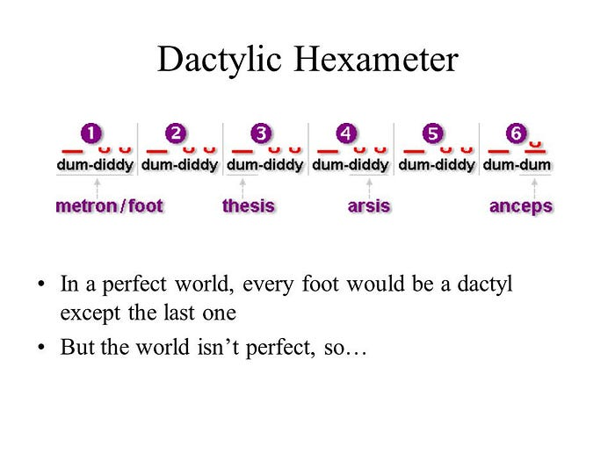
Illustration by Harvey Riley
Dactyl in Greek means finger (e.g. pterodactyl = wing finger) and in poetry it is used for a “foot” which consists of one long note followed by two short ones, denoted as follows “– u u”. The 2 short notes can be substituted by one long note, making the foot “ — — “. So a full hexameter is “- u u | “- u u |“- u u |“- u u |“- u u |“- u u | “ or “Di didi Di didi Di didi Di didi Di didi Di didi”. In theory any of the “didi”s can be replaced by a “Di”!
However it is far from easy for a modern scholar to work out this meter in the Latin without some effort. But be aware the other commonly used Classical meter, the iambic pentameter, continued in use, and its most famous user was Shakespeare. “Now is the winter of our discontent” and “To be or not to be that is the question” are iambic pentameter.
The Life Of Juvenal
I said earlier there is very little undisputable information about the life of Juvenal. There are 13 biographies of his life including the Vita Iuvenalis from the 10th C AD, but these are now regarded as extrapolations from his satires. Most derive from the work of a commentator called Probus. Around 390AD Ammianus Marcellinus, the historian, wrote that aristocrats were reading Juvenal with enthusiasm but apart from that there is little or no surviving reference to Juvenal after he died. The only references to Juvenal during his life are by the epigram writer Martial who addresses Juvenal in this work.
In the most recent edition of the Penguin edition Peter Green says there is almost no autobiographical information in the Satires. This is true, but unfortunately other than Martial we have nothing else to go on. Juvenal’s full name was Decimus Junius Juvenalis. The most probable date of his birth is 55AD according to the ancient biographies and this does fit with the material in the Satires.
Juvenal was from Aquinum which is about 80 miles SE of Rome (near modern Monte Cassino). We can be almost certain about this, because In Satire III l 318–321 Juvenal has his friend Umbricius saying to him “if ever you return from Rome to your own Aquinum”. As Juvenal seems to have spent most of his time in Rome, it is reasonable to conclude Aquinum was his family home. Two inscriptions were found in the 18th C near Aquinum, a dedication to a shrine to Ceres by Iunius Iuvenalis, and a vote of thanks to the same man by the citizens. Both are now lost but also neither can refer to our Juvenal, as one of the references on the inscription is to the Dalmatians, placing it around 30 years later than Juvenal. That was the time when Rome came up against that tribe. However it does show the “Juvenal” family must have been from the town. Modern critics have noted Juvenal showed more respect to Ceres than any other deity.
It is thought he was the son or adopted son of a wealthy freedman. The “Lives” say he practiced rhetoric until his middle age. The term rhetor is a Greek word, effectively a practitioner of rhetoric. The term was used to cover both the equivalent of a modern lecturer or professor, the person employed to carry out the third and final stage of a young man’s education, mainly around argument and public speaking, and also someone speaking in the law courts, i.e. the equivalent of a modern barrister. Juvenal would have been the barrister type of rhetor.
That his family was wealthy is assumed because Juvenal does not appear to have pushed his way to the top in that career. He chose to write satires later. He would have to have possessed reasonable funds to make that choice, or had a very wealthy sponsor.
Juvenal became friendly with Martial who was around 15 years older than him. Martial is possibly the most famous Roman writer of epigrams, short sayings or poems which are expressed in a witty fashion. Martial referred to Juvenal twice in Book VII of his epigrams, published around 92AD. He first complains about an unknown person who tried to come between them (VII, 24) and then writes (VII, 91) that he sends him some nuts for the Saturnalia festival, which was held in late December, and consequently later some elements of it were merged with Christmas.
10 years later in 102AD after Martial had moved to Spain he gloats to Juvenal in Epigrams Book XII, 18 of his pleasant life in Bilbilis in Hispania Tarraconensis (near the modern town Calatayud, Zaragoza) compared to Juvenal trudging through the crowded streets in Rome in a full toga on his way to a meeting with a client. The description does sound like that of someone involved in work in the law courts. The earlier poem also called Juvenal “facundus” — eloquent — a term applied to rhetors and lawyers, so Martial does imply that Juvenal was involved in the legal process.
Whether Juvenal ever served with the army as well as practicing rhetoric is not known, though there a view that his references to certain places, including Britain, and particularly Egypt as we will see in the next chapter, suggest that he actually went there for some reason.
The ancient biographies believe Juvenal was banished to a remote part of Egypt for a while, and one even suggests Scotland, because he had attacked an actor (Paris) who had influence with the Imperial household in one of his satires. The banishment was ordered by Domitian or Trajan, and he was later recalled. There is even a suggestion he was exiled to Egypt when he was 80 with a military command (as a joke). None of this can be proved.
Highet is convinced Juvenal was exiled to Egypt. Green did not think there was any evidence when he wrote his first translation in the 1960s but in the later edition from 1998 he has changed his mind and thinks it more likely. The references to the actor Paris are in Satire 7. Although this satire was not published till later, parts are thought to have been written, in draft at least, around 92AD. Lines 87–89 say “for it is Paris who appoints many to military commands; it is Paris who puts the golden ring round the poet’s finger after 6 months of service”. It is more likely this is the Paris executed by Domitian in 83AD than the one executed earlier by Nero. This Paris did have influence at court and was admired for his performances by wealthy Romans and the emperor’s wife. But he was accused of having an affair with her, and this led to his execution. The assumption is Juvenal had recited this during Domitian’s reign and was informed on by a Palace spy. So an exile around the mid 90s AD is possible, with a recall after Domitian’s death in 96AD. However Satire VII was not published till much later, raising some doubts about this argument. Juvenal also references Paris in Satire VI when referring to a senator’s wife who eloped to Egypt.
Green also thinks that Martial’s address to Juvenal in 102AD is rather less friendly than the earlier one, and wonders if that might have been as a result of the exile. Also note that one of Martial’s Epigrams, XI.13 is dedicated to Paris and calls him the “wit of the Nile” so he may have had more than one reason to be cooler towards Juvenal.
Juvenal refers to Egypt several times in his work, usually in an unflattering way. There is a phrase in Satire 15 on l 45, in which Juvenal is particularly scathing about Egypt, ‘quantum ipse notavi’ — “as I have noted myself”, which implies he did live in Egypt for a time. Many of the places he refers to are in Upper Egypt so that might fit for a spell in exile.
The satires cover historical events as if they were fairly recent, for example Satire 2 refers to the campaigns of Agricola in Britain, around 80AD, Satire 4 refers to the death of Domitian (96AD), and Satire 12 mentions the construction of a new harbour at Ostia which was in 104AD. Satire 13 refers to the consul Fonteius who held that office in his 60th year. He was born in 67AD, so by aligning the dates this Satire may well have been written in 127AD, or just after. So in general we know that these specific Satires were written or published after those events, but not exactly when, and the other satires must have been written within the same timeline. It also does confirm that most if not all Satires were written in the second half of his life.
It is thought Juvenal may have received a small patronage from the Hadrian in his later years, and lived and worked from a smallholding near Tivoli, where Hadrian had his enormous and palatial villa complex. He refers to his “Tiburtino… agro” in Satire 11, l 65, Tibur being the Roman name for Tivoli. It does seem he toned down his satire in later life. The general view is he survived the Hadrian but died soon afterwards around 138AD, which means he was over 80, very old for a Roman.
The vast majority of what I have just said is assumption and speculation. We really cannot prove any of it for certain other than the comments of Martial and the inferences from the surviving work.

Chapter 2 — The 16 Satires
Juvenal In The 2020s
Before I review of each of the Sixteen Satires myself, let me point out that some of the targets of Juvenal’s satire will be inappropriate, triggering, and offensive to some 21st C AD audiences. I will do my best to be as neutral as I can, and present what is there and how I interpret it.
By 2020s standards Juvenal could be accused of being homophobic, racist, and misogynist in some satires. But this is 1st & 2nd C AD Roman culture he is targeting, not the 21st C AD western culture. It is unlikely he was alone in his views, otherwise no-one at all would have been interested in them, and none of his work would have survived. There is no merit in applying our culture’s stance to his.
Juvenal is targeting hypocrisy, and abuse of power and privilege in many cases, just as people do today, as well as mocking things and people he finds stupid, and things he just does not like. That is what satirists have done throughout the ages. When you look beyond the headline comments at some of the detailed issues Juvenal rails against, they are not all that different to today, just another place, another time, with its own powerful leaders. In the 1stC and 2ndC AD — Caligula, Nero, Domitian, Trajan. In the 21stC AD — Johnson, Trump, Putin, Starmer and many others.
The Books
There are 16 surviving Satires and these were published in groups, referred to as Books, and remember Juvenal called them libelli, little books. As far as we know these are all the Satires Juvenal published, though Satire 16 is incomplete. The Books are as follows:
- Book I: Satires 1–5. Published around 110–112AD.
- Book II: Satire 6. Published around 116–117AD.
- Book III: Satires 7–9. Published around 118–121AD.
- Book IV: Satires 10–12. Published around 123–125AD.
- Book V: Satires 13–16. Published around 128–130AD.
Note that the above dates are the years in which it is believed the Books Of Satires were published, not when the Satires were drafted, written, or even first recited. We do not know for sure when each Satire was first written, we can only derive a date based on verses in them which refer to actual events for which dates are known or at least, more certain. If Juvenal was exiled around 92AD for a verse from Satire VII published around 121AD then one has to assume that some of Satires were drafted/written/recited quite a few years earlier. This particular date discrepancy is why some writers thought Juvenal was exiled when he was older, possibly by Hadrian. But that contradicts the view that Nerva or Hadrian recalled him and that he may have enjoyed a small Imperial patronage. Nothing is simple or straightforward with Juvenal’s chronology.
There is not a lot of information available on how a Roman writer actually published a work. One view is that the books were first published on scrolls in the 1stC BC. In the 1stC AD Roman publishers developed the codex format, similar to pages in a book now. Books on animal skin or parchment pages were stitched together.
Publishers used slaves to copy out selected manuscripts. These were then sold in shops. There was no copyright law in the Roman Republic or Empire. So publishers did not have to pay money to the author of the book. The only way the author could make a living out of their work was to be sponsored by a wealthy Roman. The patron, as he became known, would often control what the author wrote about. The writer also had to give readings of his work to the patron’s friends at parties. So offending the patron, or even worse, the wealthy and the powerful was not a good idea.
To derive a date of 110–112AD for Book I, these references are used: Satire I contains a reference to the banishment of Marcus Priscus, who was tried in 100AD; Satire 4 refers to the death of Domitian, 96AD; Satire 2 refers to Agricola’s campaigns in Northern Britain, 79–83AD; Satire 2 also refers to Histories and Annals. This is likely to be the Histories and Annals of Tacitus, published 104–109AD.
To derive a date of 116–117AD for Book 2, references to floods, earthquakes, and a comet in the East have been noted. A comet was seen in Rome in late 115AD, and an earthquake is recorded at Antioch just afterwards. So 117AD seems a reasonable assumption.
I have already identified that some or all of Satire 7 was written much earlier than the publication date of 118–121AD. However the Satires in Book III are the first group of Satires where Juvenal is complementary towards an Emperor, so it has been assumed publication was before Hadrian began touring the provinces from 121AD onwards.
Other than the harbour construction at Ostia in 104AD there is nothing in the Book IV Satires to help us date it. So the date of 123–125AD just fits in the date sequence of the other Books.
As well as the reference to Fonteius in Satire 13 that I mentioned in Chapter 1, Satire 15 covers events in the consulship of Aemilius Juncus 127AD, so Book V’s date of 128–130AD seems justified.
Given that Juvenal goes almost unmentioned after his death until the 4th C AD, it is perhaps remarkable that most of his work has survived and is therefore available to us. Copies of his work would have to be produced by hand by scribes so how many 2nd C AD scrolls from publication date survived until then is anyone’s guess. Copying by hand is almost certain to introduce errors and it is possible verses were changed. So how much of what we have is truly original Juvenal again is not certain.
Many manuscripts from later years have survived but because of copying there are differences and there has been a lot of debate by scholars as to which is closest to the original. The most reliable is thought to be Manuscript P, the Codex Pithoeanus Montepessulanus, a 9th-century manuscript based on an edition prepared in the 4th C AD by a pupil of Servius Honoratus, the grammarian. Apparently Manuscript P disappeared sometime during the Renaissance and was only rediscovered around 1840. Many scholars think even Manuscript P contains many insertions but Peter Green think it suffers more from gaps. But unless some surviving 2nd C AD scrolls of Juvenal are recovered on an archaeological dig, we will never know for sure.
Many writers of Roman history and daily life, as well as modern novelists who set their stories in Ancient Rome have been grateful to Juvenal for his descriptions of just that, daily life on the streets and in the homes, not just of the rich and powerful, but of the poor in their tenement blocks and slums. His words create a vivid picture of those times and are probably the best contemporary descriptions we have.
For that alone, Juvenal is worth a read in the 21st century. Here are the 16 Satires:
Satire 1 — Reasons To Be Satirical
The first Satire introduces Book I of Juvenal’s work. It is known as the “Programmatic” satire because it explains why Juvenal is writing satire as well as some of the topics he will cover. He complains he has to listen to established poets and newcomers writing the same tired old rubbish based on mythological events, or even historic ones such as Sulla’s retirement. He is also unimpressed by a new breed of social climbers using dubious means to advance themselves in terms of position and wealth. Sound familiar?
Juvenal thinks he can do better than other writers by writing satire: At l 30 he writes one of his well-known phrases ‘difficile est saturam non scribere’ —” It is hard not to write satire”. Very true in 2026. So much is going on that he disapproves of, which other writers do not criticise adequately. He cites Horace who also wrote satire, before outlining more behaviour that he considers outrageous, particularly greed and being over acquisitive. At the start I mentioned his comment about his work being a hotchpotch of what people do, and this is around l 85.
Juvenal then describes critically the Roman custom of patronage, and this has been very useful material for many writers over the years, and even today. Roman society was structured and many people were very dependent on someone on a higher rung of society for work or handouts. We are given a picture of people thronging at the door of their rich patron each day hoping for favour of some description, perhaps an invitation to dinner, or a specific task which might earn a reward. The patron may be a magistrate or person of influence, he could be as high as a Consul. Everyone is after a handout — the Latin word is sportula which is a little wicker basket used to hand out portions of meat to the poor or handing food round at dinner parties. It has effectively come to mean dole. The crowds wait to hear the rich man’s crier or bouncer — praeco — call their name out as that means they will get something that day. The Cambridge Latin Course includes this type of scene in one its chapters in Book IV.
At the end of the satire Juvenal says he will play safe by only targeting dead people in his work, though he does sometimes use people he thinks are of no significance. Otherwise he conceals the real identity with a fictitious name.

Satire 2 — Homosexuals And Hypocrisy
The second Satire is more controversial and some argue it is a denunciation of homosexuals, particularly those who hide their sexual preference under the guise of Stoicism, and other hypocrites who behave inappropriately (for Juvenal) but criticise others. Stoics believed that the principles of logical thought reflect a cosmic reason instantiated in nature. Stoicism is said to be the quality of experiencing pain or trouble without complaining or showing your emotions, so such behaviour ought to be at odds with their beliefs.
It is perhaps not surprising that the critiques I have looked at struggle with this Satire. The Loeb edition of Juvenal which includes the text and a translation by G.G. Ramsay was published in 1918. Ramsay provides the title ‘Moralists without Morals’. Highet was writing at a time when homosexuality was still illegal in the UK. Green’s first translation was on the cusp of the mid 60s legislation changes, and Barr (who comments on the Rudd translation) wrote at a time when attitudes were still evolving.
In Roman society attitudes changed over the years too. Juvenal seems to focus more on a type of person or a type of behaviour rather than an entire group, and it is the hypocrisy that annoys him most, i.e. people who preach morals that they don’t practice. Do as I say, not as I do. Over 100 years ago that is what Ramsay saw.
Nevertheless there are some uncomfortable comments for us today, At l 23 he writes ‘loripidem rectus derideat, Aethiopem albus’, translated as ‘Let the straight legged man laugh at the cripple, the white man at the Ethiopian (i.e. black)’ rather than put up with a hypocrite. But do not forget this would be normal for Roman society at his time. Even the Emperor Claudius was mocked for being a cripple.
Amongst the examples of potential hypocrites he believes no-one would tolerate he lists the “three pupils of Sulla”, i.e. the second triumvirate including Octavianus (Augustus). He has them complaining about proscriptions even though they used them. Juvenal thinks the people he is criticising are as ludicrous that.
Juvenal then comments that women do not behave in this way and puts words into the mouth of a fictional female Laronia lambasting men for homosexual pleasures. This is slightly odd, lesbianism was known in Rome. As we will see Satire VI is regarded as an even more excoriating denunciation of women and in that Satire he tells his (male) audience they might be better off with a young fellow than a young lady! So this seems like contradiction. Or Juvenal is just having a swipe at different groups at different times.
The satire has more examples of absurd fictional male (homosexual) behaviour and ends by saying that the many people Rome has conquered would not tolerate such goings on. This includes a reference to the conquest of northern Britain and beyond by way of example. A little more on that later.
In “Juvenal Revisited”, Vlieland calls this Satire “Gay Scene” and his pseudo-translation reads that way. My view is Juvenal is taking a stance that some “right on” alternative comedians take today, no target is sacred, everything is fair game. I doubt he was actually anti-gay, I think he found certain behaviour an easy target and knew his audience would as well.

Satire 3 — Rome Is A Dump
The 3rd Satire is probably Juvenal’s best known. It has inspired imitations, notably Samuel Johnson’s “London” poem in 1738, as well as proving a rich source for historians and novelists for information on living conditions in Rome either side of 100 AD.
In the Satire Juvenal expresses his disappointment that his friend Umbricius is leaving Rome for Cumae in the bay of Naples. He recounts what Umbricius said to him in the Grove of Egeria near the Porta Capena before he departed. The main part is effectively a monologue by Umbricius explaining why he is leaving.
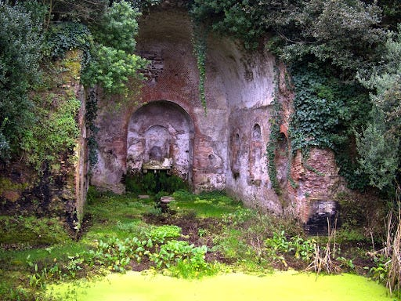
Egeria’s Shrine Today (Photo: Italian Writer.it)
Umbricius says that he has been driven from Rome because there is no longer any room for honest men, only liars and paupers; that the only way to become the client of the rich and powerful is to learn their guilty secrets. He says that Greeks and Syrians, who are willing to lie and cheat and do whatever it takes, are taking the jobs of the native Romans. This might sound a bit familiar, nothing is that new is it? The words are in Umbricius’s mouth so it does not necessarily mean Juvenal is a xenophobe, but clearly he knew people who were. And it is ironic that Umbricius is heading for Cumae — it was a former Greek colony.
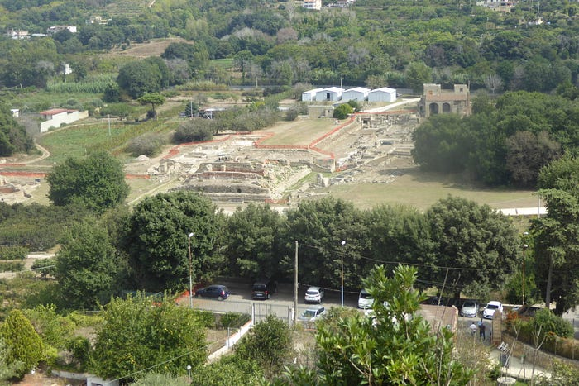
Roman Cumae (Photo: Peter Coglan)
Umbricius adds that only rich men are believed on their oaths; that the poor are thrown out of their theatre seats by people who have more money or consider themselves better; that he can never hope to marry an heiress or to receive a legacy; that prices are too high in Rome, even ordinary food costs too much. He adds that some lifestyles are too pretentious, people are living on credit to keep up appearances. Again, this is familiar territory for most periods of history.
Then we come to the part which is most famous, life on the streets of Rome. Umbricius says that there is a constant danger of houses falling down because too many dwellings are in a bad state of repair or badly propped up with supports. Also that most properties are at risk of burning down. And when they do someone will come forward to take advantage of the disaster. Here we see the description of living conditions in a Roman insula — tenement blocks with shops at ground level and flats on the upper floors which get steadily worse as you go up each storey. Then the streets are so crowded and so noisy with people and wagons all day and night, sleep is almost impossible. The rich are carried safely through the streets but the rest are jostled and battered by other people and goods overhanging on wagons.
At night there is every chance you will be hit on the head with some old pot thrown from a window or it will smash right by you on the pavement. Or you could be showered by the contents of a chamber pot, you could be accosted and mugged in the street as you make your way home. Before leaving home at night to go out to dine you should make a will.
So life in Rome is shown as extremely grim. Finally Umbricius says it is time to depart and begs Juvenal to let him come from Cumae to visit him whenever he returns to his native Aquinum, This is the reference to Juvenal’s origins I mentioned earlier and it also refers to Ceres, to whom someone from Juvenal’s family dedicated a shrine at a later date. He would also welcome an invitation to hear his Satires in Aquinum, not Rome.
For all that this Satire paints life in Rome as darkly as possible, as far as we know, Juvenal lived there most of his life, and presumably put up with all the disadvantages he attributes to Umbricius. Whether he disliked Greeks and other immigrants to Rome himself or whether he is just reflecting the views of others is not clear, he reserves more disdain for Egypt elsewhere. But for a contemporary description of life in Rome around 100AD, this is hard to beat.

Satire 4 — The Big Fish
Apart from an initial blast at a stock character called Crispinus, whose general behaviour Juvenal describes as abominable, for buying a fish for a ridiculous price and then eating it himself rather than using it to gain favour with someone else (having his cake and eating it?) this Satire is aimed at the now dead Domitian and his court.
Juvenal tells the tale of another fish, a monster turbot caught in the Adriatic Sea near Ancona. The fisherman realised he could not sell it so he presented it to Domitian, who then summoned his Privy Council for advice on what to do with it as he did not have a dish big enough. Various fellows come forward, scared of what Domitian might do to them, and offer pompous advice or flatter him that this is an omen that he will capture a mighty foreign king.
Finally one councillor proposes a dish be made big enough, rather than cut the fish up and the motion is carried. The Satire closes with a comparison to feasts at Nero’s court, and comments that Domitian had called an emergency meeting for something so relatively trivial and in the end could not tell the difference between such matters and a real emergency. As a result he had sealed his own fate, i.e. his assassination.
It is thought that the Satire is in part a parody of an epic poem by Statius praising Domitian’s military prowess. It is certainly a Satire on excess. The Satire also seems to be me to be about individuals and groups losing all sense of proportion, Crispinus, Domitian, and his Privy Council losing theirs.
At the time I was rereading this Satire and rewriting this synopsis, I did wonder what Juvenal would have made of the behaviour of our politicians and news media in the last few years. So many actions and events produce an overblown counter action. Our news media and meteorology reporters use phrases like blowtorch temperatures and snow bombs as overblown reactions to a weather forecast. I looked for a current 2026 equivalent.
Cometh the hour, as they say. Step forward Darren Jones, the Chancellor of the Duchy of Lancaster, who has a wont for producing twee videos on how to use tech, when he clearly knows nothing about it. This very weekend (time of writing) Darren has announced: “Each department in government will now have its own delivery unit, led by a senior civil servant. And every Secretary of State and Minister of State will be given a new ‘delivery advisor’ in their private office to support this work. These new delivery functions will be accountable to both their Secretary of State and to my team”.
What on earth? That sounds like the spec for a system based on a late 1980s back office controller platform using tech from the German company Nixdorf. Meaningless drivel which will cost more money we don’t have and require more committees inspecting monster turbots. Oh, I do wish a 21st C Juvenal would emerge to ridicule these people.

Satire 5 — No Such Thing As A Free Lunch
Juvenal addresses his 5th Satire to a character he calls Trebius, a client of a rich man he calls Virro. This reminds us of the patron-client we saw in Satire 1. When clients gathered every morning at their patron’s door they would hope for some work or possibly a dinner invitation for that day as a reward for their working on their patron’s behalf.
Juvenal is advising Trebius to have more self-respect than to accept such a dinner invitation. He thinks Trebius would be better off begging or dining off scraps thrown out for the dog. He describes such a dinner as one where the patron dines in style on the finest food and wine, whilst the poor client is given food leftovers on broken pots and poor quality drink in broken cups. Not only that but the wine for the poor end of the feast is so bad that those who drink it start fighting and throwing things, so he would end up battered and bleeding. The smart servants will look on him with disdain and he will be served by a thug who is more likely than not to mug him on his way home.
The rich man is offering the dinner to ease his conscience for the work the client has done but also insult him with a meagre food portion that is not fit to eat because that is all he thinks the client is worth. Juvenal provides many examples of the fine food the rich man enjoys and the rubbish his clients will suffer. If Trebius is happy to go back for that sort of meal for a second time then he deserves what he gets. He might as well offer himself for a public flogging.
Juvenal demonstrates that the patron-client relationship around which Roman society was organised was, for the most part, very one-sided. Whether he ever suffered such a dinner himself we do not know; in all likelihood he had acquaintances who had, and it is entirely possible he was at the whim of hard-hearted and tight fisted patrons at various times of his life.

Satire 6 — Mean Evil Women
Satire 6 is another very well-known one. It is the longest Satire and was published as a Book on its own. Juvenal laments what he sees as the decay of feminine virtue, and uses a series of examples on the degraded state of female morality apparently to dissuade his friend Postumius from getting married. It is over the top and it has been considered a misogynist rant. As with Satire 2, it is specific behaviour that has angered Juvenal, though his approach is scattergun.
The poem opens with a parody of the golden age myths and of the Ages of Man: Gold, Silver, and Iron when crimes started and became steadily worse. The goddesses Chastity and Justice then left earth in disgust. Juvenal asks Postumius if he has gone insane, he might as well top himself or sleep with a youth. So the reverse of Satire 2 it would seem, and taken literally, not a suggestion that is welcome in our time either.
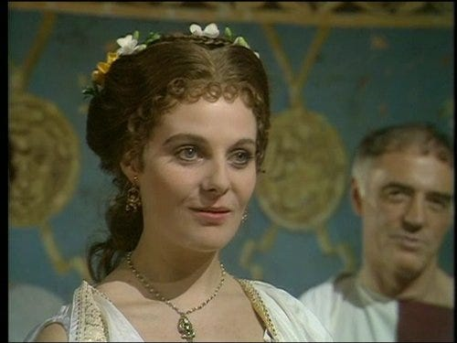
Messalina in the BBC Drama I Claudius (Photo: IMDb)
Juvenal then relates a series of examples of why women and marriage should be avoided. He describes the notorious adulterer, Ursidius, who wants a wife of old-fashioned virtue, but is insane to think he will actually get one. He then gives examples of lustful wives, such as Eppia, a senator’s wife, who ran off to Egypt with a gladiator, and Messalina, wife of Claudius, who used to sneak out of the palace to work at a brothel. We do not know how true this is, but Suetonius certainly wrote some salacious stuff about Messalina. Her antics were featured in the 1970s “I Claudius” drama.
Juvenal goes on to say that many greedy husbands are willing to overlook a wife’s behaviour for the dowries they receive. He argues that men love a pretty face not the woman herself, and when she gets old, they can just kick her out.
He then discusses pretentious women, and claims he would prefer a prostitute for a wife over someone like Scipio’s daughter, Cornelia Africana, supposedly a perfect example of a virtuous Roman woman, as virtuous women are often arrogant in his view.
Juvenal then accuses women of being argumentative and just wanting to rule the home. Then they move on to their next “victim”. He says that a man will never be happy while his mother-in-law still lives, as she teaches her daughter bad habits — I suppose comedians like the late Les Dawson would agree with that!
Juvenal says that in the past it was poverty and constant work that kept women chaste. It is the excessive wealth that came with conquest that has destroyed Roman morality with luxury. We then have a passage which recent editors have inserted here as the ideal location but not all manuscripts concur. It contains my favourite Juvenal phrase, and perhaps one of his best known when asking if eunuchs guard a wife, how does one know they are a eunuch (without the obvious check!). The Latin is ‘quis custodies ipsos custodiet’, — “who will guard the guards themselves?” There are so many situations today this phrase can be applied to.
Juvenal carries on by criticising women who try to interfere with masculine business and are always gossiping. He says that they make terrible neighbours and hostesses. He does not like women who think they are grammar experts and are always picking up on others’ errors. He cannot stand rich women who only make themselves up for their lovers, and are cruel to their household slaves.
He thinks women are by their nature superstitious, and too easily believe the words of the eunuch priests of Bellona (the war goddess) and Cybele (the mother of the gods). Others are fanatic acolytes of the cult of Isis and its charlatan priests, or listen to Jewish or Armenian soothsayers or Chaldaean astrologers, and get their fortunes told down by the Circus Maximus. Worse than those is a woman astrologer who others consult. Eat your heart out Mystic Meg!
Whilst poor women are willing to bear children, rich women just get abortions, although at least that prevents the husbands from being saddled with illegitimate children. Juvenal adds that half of the Roman elite is made up of abandoned children whom women pass off as those of their husbands. Women will even drug and poison their husbands to get their way, like Caligula’s wife, who drove him insane with a potion, and Agrippina the Younger who poisoned Claudius. Again Suetonius could be an influence here.
Finally Juvenal asks the reader if he has slipped into the hyperbole of tragedy. However the women of ancient tragedy such as Medea and Clytemnestra were less evil than modern Roman women, because at least they did what they did out of rage, not just for money.
So, was Juvenal a misogynist? Did he have a bad betrothal or marriage? Was he writing on behalf of close friends who had suffered? We just don’t know. All we can say is this is quite some rant.
Satire 7 — No Profit In Poetry
Satire 7 starts the 3rd book of Satires and from hereon in Juvenal tones things down somewhat. Whilst initially saying that the new Emperor (Hadrian?) is the best hope as patron of the arts, the Satire is something of a moan about the lack of patronage available to anyone involved in literature and the Arts.
Juvenal says earlier poets such as Horace and Virgil enjoyed patronage and could not have achieved what they did without it. The issue also affects historians, barristers (remember, he was probably a rhetor in his earlier life), and teachers. Fathers expect good education to be delivered but do not want to part with the money to pay for it.
It is this satire which has the references to the undue influence of the actor Paris at a previous Emperor’s court. These are the lines which it is thought could have led to Juvenal’s banishment. As I have noted, the dates just do not fit. Perhaps Juvenal included lines from an earlier, unpublished version of this satire when he knew it was safe to do so, but it does show that satirists in Roman times had to be careful. Unlike today they could not satirise the living, particularly those in power. Mind you, I do wonder if we might head that way now in the UK. Just a personal reflection, observing some of the outraged reaction from certain parties on social media when it comes to ‘Freedom Of Speech’ or indeed any controversial topic.

Satire 8 — Noble Thoughts
Satire 8 offers advice to a man called Ponticus about to take up high office (consul or praetor). It is of no use being of noble birth from an aristocratic family if your actions are not also noble. Virtue is the only real nobility. Juvenal says there is no point in saying you are posh or upper class if you spend all your time getting drunk and gambling. If you are posted abroad then act the part as an ambassador for Rome rather than trying to rip off the local population.
Juvenal gives plenty examples of so-called nobles who have behaved badly to make his point but his overall advice in this satire is a positive one. His most well-known example is that of Cicero who was from a middle class family but was able to thwart the upper class Cataline in 63–62 BC.

Satire 9 — The Dumped Gigolo
The 9th Satire is thought to be an early Satire published much later than it was written. It has some connections with Satire 2 in that it covers one type of homosexual behavior in a less than flattering way, and Satire 4, in that the villain goes by the name of Virro again. Having said that, Juvenal does show sympathy for a friend called Naevolus, who is presented as bisexual, rather than Virro, who is a homosexual masquerading in a marriage.
The Satire is presented as a conversation between Juvenal and Naevolus who he encounters in a sorry state after being “dumped”. Naevolus has been in a relationship with Virro who wanted him not only as a lover for himself, but also as someone to “service” his wife and father a child for him. Ramsay (Loeb edition) sums the Satire up in one short sentence calling its subject a “disgusting offence”. It is fairly graphic, even by 21st C standards, in the way it describes the menage-a-trois between Naevolus, Virro, and Mrs Virro, and the details of their intimacy.
The relationship ends badly for Naevolus who thinks he will now be reduced to poverty and begging whereas Virro will just seek another “2 legged donkey” for his pleasures. Juvenal wishes Naevolus well and thinks he will survive, but Naevolus is resigned to a grim fate. Basically not a Satire for a short, uplifting read, or for anyone easily offended.

Satire 10 — Be Careful What You Wish For
This Satire is about the problems with hopes and dreams, as football fans often say “It’s the hope that kills you”. The Satire lists examples of how what people wish and pray for can hurt or even kill them. It is one of the best known satires and it contains 2 of Juvenal’s best known sayings.
Juvenal starts saying few people can tell good from evil, and that people always seem to desire what will hurt them most. Many love money even though it can bring ruin and death, whereas the poor man does not need to be afraid of robbers or poisoners. The sages of old, whether they were always laughing or always weeping, led better lives. The philosopher Democritus would have been unimpressed by a current Roman praetor’s attendance at the games.
It is in this early section we encounter another of the very famous quotes on l 80–81 ‘duas tantum res anxius optat, panem et circenses’, which means “longs eagerly for just 2 things, bread and circuses (games)”. That is all people care about these days, he says. Perhaps a curry and a football match in 2026?
Some people like power and prestige too much, and ambition brings down those who cling to power. I wonder if Shakespeare had this in mind with Macbeth: “vaulting ambition, which o’erleaps itself”. An example he gives is Tiberius’s strong man/enforcer Sejanus, ultimately hated, executed, and torn to pieces by the mob. It would be better to live a peasant’s life. Boys may long for the eloquence of Cicero but that eloquence played a part in his demise.
Some desire to be victorious in war, but in the end, fame like that is only carved on the walls of tombs, which themselves will crumble and fall, for example Hannibal, Alexander and Xerxes. What remain of them now? Some people pray for a long life, but old folk are a burden to themselves and to their friends, have no enjoyments and suffer all sort of illnesses and diseases. Sounds rather too much like attitudes in the 21st C AD, doesn’t it? You are a burden, we have a jab for that!
Mothers often pray for good looks for their children, but chastity and beauty rarely go together and there are many example of beauty resulting in tragedy.
Juvenal concludes that it is best to leave it to the gods to decide how things should be, and we have another well known saying on l 356 ‘orandum est ut sit mens sana in corpore sano’, which means “one should pray for a sound mind in a healthy body”. That is the best thing to wish for, and try to live a good and quiet life. I am not sure how old this saying is. Earlier this year I found a very similar saying in the Bhagavad Gita, the Krishna and Arjuna story. It predates Juvenal by around 3000 years! So knowledge travelled the world even then.

Satire 11 — Eat Within Your Means
In the first part of Satire 11 Juvenal advocates simple meals in a time of individual austerity rather than dining extravagantly on credit and going broke. Leave the Roman equivalent of a Master Card at home. He offers general advice on living within your means. In the second part of the Satire he invites a friend, Persicus, to a simple meal, all home-grown on his smallholding at Tibur (modern Tivoli) and it is assumed that this information is autobiographical.
The meal will be served on simple plates such as all people used in times gone by, not on fine dinner ware and on ornate furniture. The meal will be served by a couple of local village lads, not over-dressed and manicured servants, and there will be no Spanish dancing girls “shaking their booty” (yes, the Latin does say the equivalent of that). There will be a simple reading of Homer or Virgil afterwards rather than a trip to the races at the Circus Maximus. Basically this is an opportunity to enjoy the simple things in life rather than trying to keep up with younger and wasteful people.
This is probably the most gentle and relaxed of all Juvenal’s satires.

Satire 12 — For Those In Peril On The Sea
In Satire 12 Juvenal is telling a man called Corvinus (“The Crow”) about a sacrificial offering he is making after his friend Catullus (not the famous poet of the same name) survived a storm at sea and made it safely back to Ostia. Juvenal is emphasising he is not after a legacy, it is just out of friendship. Catullus had been fortunate to survive but also unfortunate because he had ditched all his precious cargo into the sea during the storm to help prevent the ship from sinking. The satire ends with a digression on where elephants are from and a harangue about how far some would go with a sacrifice if they thought it would be to their advantage. It could be elephants, or the ultimate sacrifice, like that of Iphigenia at Aulis by Agamemnon in order to get the winds to change direction for the fleet to sail to Troy. No-one should go that far.

Satire 13 — Keep Calm and Carry On
Satire 13 is based on what is known as a consolatio, a poem intended as a formal expression of sympathy to a bereaved person. Juvenal is being ironic in using the style to console a man named Calvinus on losing 10,000 sesterces (probably a few hundred pounds) in a loan which will not be repaid. He thinks Calvinus is going over the top in his reaction given he has more money than he knows what to do with. He thinks it is a sign of the times and it could be a lot worse. In the end the debtor will get his come-uppance one way or the others. Calvinus should calm down and let events take their course.

Satire 14 — Teach Your Children Well
The subject of Satire 14 reminds me a little of the 1970 Crosby Stills Nash & Young song “Teach Your Children” that I have used for the heading. Whilst Graham Nash’s song was not inspired by Juvenal’s Satire, the message is the same, children pick up on the habits, examples, and lessons of their parents or elders and repeat them, possibly even worse.
So if a father is excessively cruel, or a mother takes a string of lovers, their son or daughter is likely to do the same. He gives an example of an over ambitious property developer who built fabulous villas on the coast and in the hills around Rome, and, of course, over spent. His son went even further and bankrupted the family fortune building even grander villas. A property boom and bust perhaps reminds us of 2008 onwards?
Juvenal also notes that a Jewish child will definitely follow the parent’s “unusual” dietary, religious, and cultural habits. Interestingly Juvenal shows an awareness of the laws of Moses (he names him), the Bible (Old Testament), and 10 Commandments, though he clearly disapproves of Jewish people in Rome flouting Roman laws and ways.
Juvenal then goes on to denounce avarice and the miserly acquisition of wealth for its own sake. Like Dickens, he would not have approved of Ebenezer Scrooge’s behaviour before he learned his lesson. He saw this as something which might destroy Rome and its empire. Perhaps that is a lesson that stands the test of time. Give children the right message, and use money sensibly rather than just acquire it to the exclusion of all else.

Satire 15 — Maneaters
If Satire 11 was a gentle one, then Satire 15 is a direct opposite. Satire 11 extolled the virtues of a simple meal. Satire 15 is grim indeed and describes the horror of an incident of cannibalism in Egypt after a battle between the townspeople of Ombi and Tentyra. Some of this satire is very unpleasant. Parts of it read like the script of Cannibalism B movie. It starts with a general rant about Egypt, and its strange religions, which lends weight to the argument that Juvenal was exiled here and hated it. Note though an interesting reference to the Colossi Of Memnon, the famous giant statues of Amenhotep III, thought in Roman times to be the hero Memnon, and the singing noises that people thought emanated from them. At some point later the Romans tinkered with the statues and the sounds stopped! These statues have featured in a number of recent TV documentaries.
Juvenal then reminds the reader of the tales of flesh eating monsters in the Odyssey before describing how ordinary people acted just as badly in Egypt. I will spare you the details of this horror tale — I don’t want to ruin your next meal. It took place on one town’s festival day. Basically both towns hated each other’s preferred religion. Once again, this sounds familiar. We have conflict without end and proxy wars over boundaries, religion and culture even in 2026.
We do not know if the story Juvenal relates is true. Highet thinks it is, particularly writing so soon after WW2 and the atrocities of the holocaust. Juvenal strangely does compare the Egyptian incident with one in northern Spain, saying at least the Spanish tribe had been forced into starvation by the Romans.
There are a couple of references to Britain (which I will cover later) in the poem where Juvenal once again dishes out his bile against the Egyptians, whose behaviour is the worst he can possibly imagine, worse than any other legendary savagery elsewhere.

Satire 16 — Soldiers Of Fortune?
The final satire is incomplete. Only 60 lines survive. Reasons speculated are that most of it has been lost soon after publication, that Juvenal died before completion, or that it was censored. The first of those is the likeliest. What survives appears to be about the unfair advantages of military service versus a civilian life, such as a properly funded pension and will. A little like the modern world until the dawn of automatic enrolment pensions perhaps? Some have suggested Juvenal may have had an unhappy time in the army, but there is no evidence he ever was a soldier.

Chapter 3: Juvenal and Britain
Britain pops up several times in the Satires. Why and where:
There is a view that Juvenal may have served in the army in Britain under the general Agricola, who led Roman territorial expansion in Britain in the late 1st C AD and advanced right into the highlands of Scotland. As mentioned previously, some of the ancient autobiographies also suggested Juvenal was exiled to Scotland, it being on the very edge of empire at the time of Juvenal’s life. We have no actual evidence whatsoever for this, but being British I am particularly interested in the mentions of Britain in the Satires, as opposed to the hundreds of other places he mentions within the Empire and beyond, from Spain to the Ganges in India, from the Arctic Circle to Northern Africa. Britain was of course, a relatively new Imperial acquisition in Juvenal’s time.
Satire 2: Conquest Of The North
In Satire 2 l 159–161 Juvenal writes ‘arma quidem ultra litora Iuvernae promovimus et modo captas Orcades ac minima contentos nocte Britannos’, which means “we have even pushed our arms beyond Ireland’s shores and the newly captured Orkneys and the Britons who put up with a short night”. He is commenting that vices he does not approve of only occur in Rome and the people Rome conquers no matter how remote do not carry out such vices. Britain was about as remote an Imperial location as you could get. Here Juvenal is actually talking about the campaigns of Agricola 79–83 AD.
Agricola advanced a long way into Scotland culminating in the battle of Mons Graupius (the Grampians?) and it is thought his troops got as far as Cawdor or Inverness.
The navy circumnavigated Britain, and Tacitus states the Orkneys were conquered, but there is no clear evidence for this. The short summer nights in northern Scotland must have been quite a shock to the Romans but they must have hated the short winter days even more. Tacitus also mentions Agricola had plans to invade Ireland but again there is no evidence he never did. He apparently believed one legion would be sufficient to achieve conquest so it is possible an exploratory visit occurred. He did give refuge to an exiled Irish king, and some Romano-British artefacts have been found in sites linked with a king called Tuathal who had been exiled around this time. So although Juvenal is not entirely accurate with his reference, from a Roman viewpoint Agricola had to all intents and purposes conquered all Britain.
Fortunately for Agricola he did not have to contend with our own self-styled ‘King of The North’. Sorry, couldn’t resist that.
Satire 4: Prince Arviragus
In Satire 4 126–127 Juvenal writes ‘aut de temone Britanno excidet Arviragus’, translated as “or Arviragus will fall from his British chariot pole”. Arviragus is a legendary, and possibly historical, British king, and the point in the satire is that a giant turbot presented to Domitian is said to be an omen that some king will be captured, or Arviragus will be throw out of his chariot.
We know nothing of Arviragus but Geoffrey Of Monmouth many years later has him as a son of Cymbeline and attributes deeds to him that are similar to Caratacus. Shakespeare then uses Arviragus as a character in his Cymbeline play. Caesar had referred to the British fighting from the pole of a chariot. Some modern writers think an Arviragus led a revolt in the early 100s but without any real evidence. Whether Juvenal’s contemporaries knew who Arviragus was, or whether they regarded the name as just some strange British fellow they had never heard of, we really do not know.
Satire 4: Richborough Oysters
In Satire 4 l 140–141 Juvenal writes ‘Circeis nata forent an Lucrinam ad saxum Rutupinove edita fundo ostrea primo deprendere morsu’ , meaning “he could tell at first bite whether oysters were bred at Circeii or the Lucrine rock or the beds at Richborough”. Juvenal is commenting on the alleged gourmet ability of Nero in being able to tell where an oyster is from in a similar way to how a wine buff today can tell where a wine is from at a sniff and a sip.
Richborough (Rutupiae) in Kent was commemorated as the landing site for the invasion of 43 AD in Roman times, when it was then on the coast. A large monument, a 4 way arch was erected, and its base can still be seen today. As such it would have been one of the better known British place names along with the capital at the time, Camulodunum (Colchester).

Rutupiae/Richborough (Photo: Peter Coglan)
British oysters were known and are referred to by Tacitus and others. Whether Richborough had oyster beds is not known and Juvenal may just be using Richborough to say British. If anyone reads the Lindsey Davis “Falco” and “Albia” novels, look out for this reference in “Pandora’s Boy”, published April 2018.
Satire 10: Whales
In Satire 10 l 14 Juvenal writes: ’quanto delphinis ballanea Britannica maior’, in English “by as much as the British whale is bigger than the dolphin” when referring to the inherited and amassed wealth of the rich as opposed to most people. Whether Juvenal ever saw any such whale we do not know and indeed large whales are not common in British seas any more. Current species that can be seen off the Scottish islands, Ireland, and the east coast of England are the Fin Whale and Minke Whale (Baleens).

Minke Whale seen near Scarborough 2023 (Photo: BBC)
Less likely are the Sperm Whale and the Orca. One guess is he was referring to the Right Whale seen in the North Atlantic, or possibly the Bowhead Whale, endangered these days and more an Arctic than Atlantic whale. Perhaps it would have been a type of whale his Roman readers had heard of and could relate to, as the Mediterranean has some large whales, certainly much larger than a dolphin or porpoise, and stories like “Jonah and the Whale” are old enough. Perhaps with Britain being remote it was assumed to be a place where “sea monsters” were more likely? It is just curious Juvenal says British whales. We know the Romans under Agricola, and Greeks even earlier, circumnavigated Britain and by inference sailed into the North Atlantic and possibly Arctic seas. Maybe they thought all those seas and the whales in them were British. Perhaps we can also assume whales were more common in British seas as there was no significant whaling industry 2000 years ago.
Satire 14: The Forts Of The Brigantes
In Satire 14 l 196 Juvenal writes: ‘dirue attegias Maurorum, castella Brigantum’ which means “destroy the huts of the Moors and the forts of the Brigantes”. This is supposed to be a father encouraging his son to perform great feats. This was published quite a while after the Brigantes had been defeated, ultimately by Agricola. Hadrian’s Wall would have been in construction and the Stanegate line of forts had been in operation a while. This could be a simple anachronism or just an example of somewhere remote and difficult to attack.

Carl Wark hill fort Derbyshire (Photo; Brigantes Nation)
Apart from Stanwick in North Yorkshire Brigantian hill forts tend to be quite small, fortified crofts in essence. Is that why Juvenal used the diminutive “castella” rather than “castra” or was that just to fit the meter?
Satire 15: British Barristers And Beyond
In Satire 15 l 111–112 Juvenal writes: ‘Gallia causidicos docuit facunda Britannos, de conducendo loquitur iam rhetore Thule’, in English “eloquent Gaul has trained the barristers of Britain, and now Thule is talking of hiring a rhetor”. In the middle of his tirade against the savage Egyptians Juvenal is contrasting how even the remotest parts of the Empire are taking on the trappings of Greco-Roman culture. Again this is an example of Britain being very remote but I think the reference to Thule is also very interesting.
You may have seen roof bars and boxes with a “Thule” logo on the top of cars and 4WDs. I am sure the company took the name from this ancient name for the farthest and most remote land in the northern seas to denote a product hard wearing in extreme weather. Various ancient writers including Virgil mention “ultima Thule” — furthest or faraway Thule.
The Romans circumnavigated Britain as per Tacitus (mentioned above). He says they sighted “Thule”, but earlier Greek references go back to 4th C BC. Pytheas of Marseille sailed into the Arctic region around 315BC, trying to establish new trading routes. There is much debate over the location of “Thule”, with the Shetlands, Norway (claimed by residents of Smøla), Iceland, and even Greenland suggested. In fact recently it has been suggested the Greeks could have got to Newfoundland, and if you look at the top of a globe as opposed to a map you can see why. I would go for Iceland but who knows. Just don’t tell a man called Donald. He will claim “ultima Thule” as his.
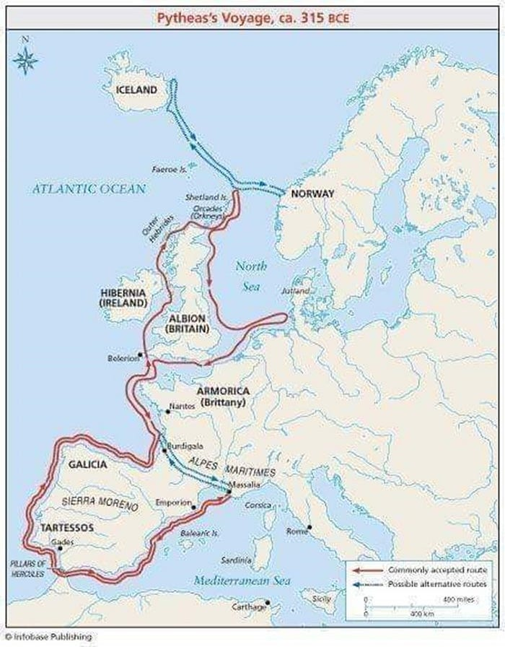
Pytheas’s Voyage (Infobase Publishing)
Satire 15: Savage Britons?
A little further down on l 124 Juvenal writes “nec terribiles Cimbri nec Brittones” — neither terrible Cimbri nor Britons — as part of a longer list of savage tribes with whom the Egyptians are being unfavourably compared. The Cimbri were a Germanic Celtic tribe, and there is an assumption that Brittones is Britons even though we have the more usual Britannos a few lines earlier.
So what do all these references to Britain show? Did Juvenal’s feet ever walk our pastures green? Did he have a lot of knowledge about Britain? I am more inclined to think Britain was somewhere he and his readers regarded as the edge of the world, an “over the hills and far away” place, or an ancient equivalent of the 20th C British colloquial reference to Timbuktu (in Mali). So for anywhere strange, wild, or remote, Britain was an ideal reference. Interestingly Rudd translates “Thule” as Timbuktu.
Juvenal’s Legacy: Satire Today
Juvenal’s Satires influenced many famous writers down the ages. I mentioned Samuel Johnson’s London already. Other admirers of Juvenal were Wordsworth, Coleridge, and Lord Byron. Apparently even politicians quoted Juvenal in Parliament for example Edmund Burke in 1775 when warning the government against plans to blockade American colonists.
Satire continued to be developed as a literary style, including full length novels, famous ones being Gulliver’s Travels by Jonathan Swift, Huckleberry Finn by Mark Twain, Animal Farm by George Orwell, Don Quixote by Cervantes. More recently perhaps, Catch 22 by Joseph Heller, Hitchhikers Guide To The Galaxy by Douglas Adams. And many others.
On the magazine front, Punch ran for over 150 years before closing in 2002 but Private Eye is still going.
The 20th C brought visual satire to mass audiences with the advent of films, and more particularly television. The 1960s spawned clever political satire such as “That Was The Week That Was”, “The Frost Report”, and comedy shows such as “Mash” and “Monty Python” contained a lot of satire.
More recently in the UK home produced visual satire on TV seems to be vanishing. There is “Have I Got News For You” to an extent, but shows such as “Bremner, Bird, and Fortune” have gone with no replacement. “Spitting Image” was successful first time round but the reboot came and went without notice.
It seems political correctness and fear of offending the self-appointed elite started to hold sway in the UK. The Americans seem better at it. “South Park” is a well known animation. There are others such as “American Dad” and “Inside Job”. Though it seems even the long-running “The Simpsons” is upsetting the sensitive these days.
Then came memes and gifs on social media in the 2010s and 2020s. The real renaissance started in 2025 and more particularly in 2026 with the use of affordable AI music and video software which can be posted on social media, particularly YouTube. The output is amazing.
I am being as topical as I can, so my examples are current politicians and issues. You know that phrase, “I won’t take any lectures from…on…”. That is what I am doing. So I should issue another trigger warning. Whereas Spitting Image delighted in poking fun at Thatcher, Major, and Reagan, we have a different type of government now, a different type of politician, more po-faced, for whom optics and narrative are as important as substance. And an easily offended audience.
I have to thank the PM at the time of writing for being such an inspiration. The sight of him at a piano as Barry Manilow singing, yes, “Mandy” is hilarious. Or a cartoon HMS Dragon singing “Sitting On The Dock In Pompey” perhaps, whether you believe a British destroyer should be active in the Eastern Mediterranean or not?


I sent you away, Oh Mandy (Crewkerne Gazette)
The Home Office created a politically incorrect purple haired Goth girl character called Amelia with all the wrong opinions to deter young people from extreme views, as part of its Pathways project. That got turned on its head and satirised so much the Pathways videos were halted. Amelia, the parody Goth girl became a Pathways parody, a new Britannia singing traditional folk songs such as ‘The Keys Of Canterbury’ and hymns like ‘Abide With Me’, as well as a counter revolutionary Japanese anime ‘waifu’ in punk rock style protest songs. Simple message, do not patronise people. One newspaper completely overlooked the beautiful folk songs and focussed on the controversial punk ones. They just don’t get satire or parody.

Amellia sings a lovely folk song (Epochalypse) Amelia upsets the newspapers (Music Of Our Time)
Perhaps some of our politicians and journalists should read Juvenal, there is plenty scope for inspiration from him, given the way high profile politicians across all the parties behave, and more so their acolytes, let alone the celebrity culture.
And Finally
So that is Juvenal, a man about whom we know next to nothing. Although hardly a prolific author, his works have influenced and inspired later writers over many centuries. I would like to suggest Juvenal still has a relevance today. Our leaders, our celebrity culture, and our self-appointed metropolitan elite are just as a good a target as their former equivalents in late 1st C/early 2nd C AD Rome were. Like Juvenal, today’s writers seem no longer able to satirise certain individuals directly, and many subjects are going off-limits. It is time for the 21st C western world to re-acquaint itself with Juvenal.

Bibliography
Epigrams VII 14, 91 Martial 92AD
Epigrams X1 13 Martial 102AD
Epigrams XII 18 Martial 102AD

Juvenal The Satirist Gilbert Highet 1954
Juvenal and Persius G G Ramsay 1969 Loeb
Juvenal The Satires Niall Rudd 1991
Juvenal The Sixteen Satires Peter Green 1998 Penguin
Juvenal Revisited C P Vlieland 2017

